eTender portal
Quick guidance for Suppliers

Version: 1.1

July 2020

A – The starting page of the portal
Direct invitations from the portal to suppliers are only possible for those suppliers, which are registered. But all ongoing tenders can be viewed by any supplier.
For all ongoing tenders simply check the WHH-Website:
https://www.welthungerhilfe.org/tenders/
For all ongoing tenders, which are administered in the WHH portal go to the following website: https://eu.eu-supply.com/login.asp?B=Welthungerhilfe

By using the latter link, you will reach the starting page of the WHH tender platform:
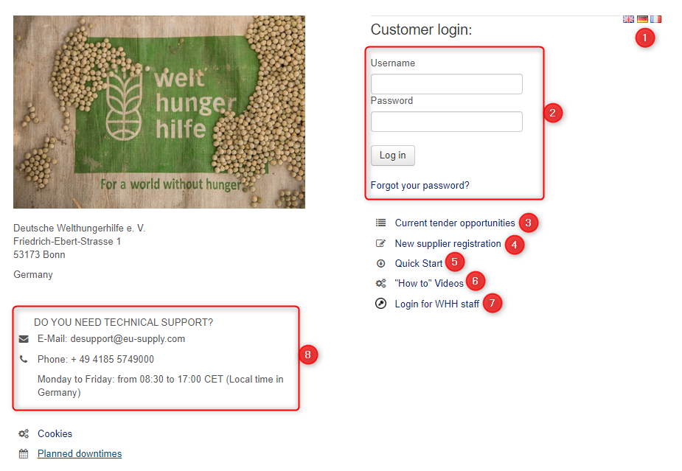
Some explanations:
1: You can change the language of the website
2: The login (after successful registration you enter here your username and password)
3: Link to the ongoing tenders of WHH
4: If not registered yet, here you can start the registration
5: This document
6: YouTube-Video which explains the use of the portal
7: Login for WHH staff only
8: In case of a technical question, you can contact the technical support during opening hours

B – How to view ongoing tenders of WHH
By clicking the “Current tender opportunities” on the starting page you will reach the following page:
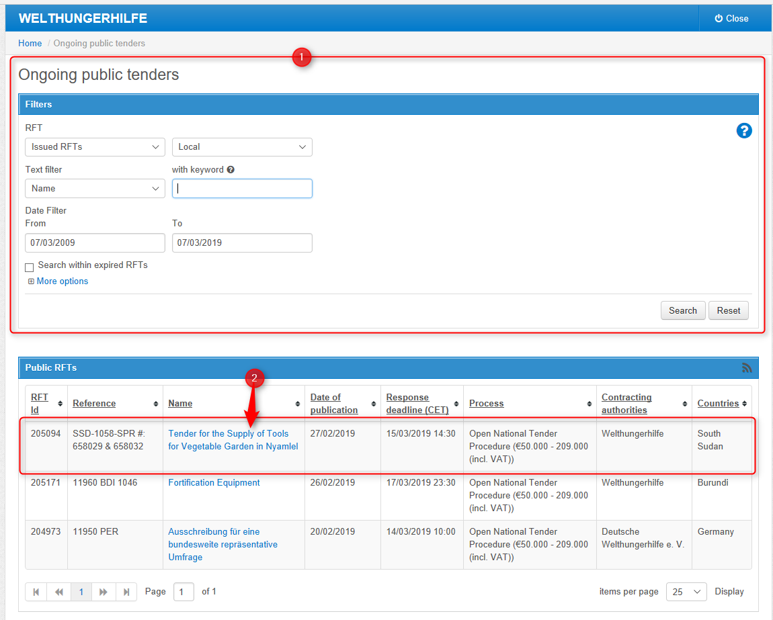
Some explanations:
1: Here you can filter the tenders (in case too many are displayed)
2: By clicking on the text of the column “Name” you will be forwarded to the information page of the specific tender from which you can review the tender documents and other information

The information page of a tender:
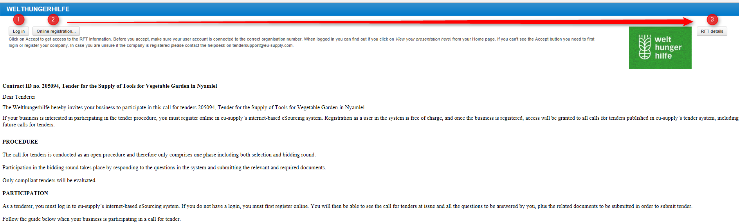
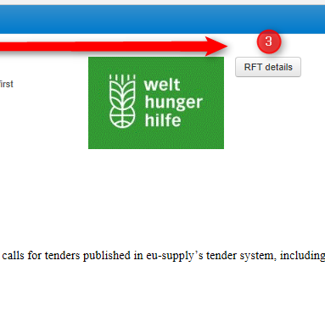
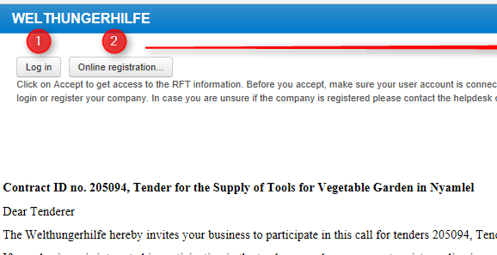

Some explanations:
1: You log on with your credentials and express your interest to participate
2: In case you are not registered, you can click on this button to register online
3: Here you can review the details of this ongoing tender

C – How to register your company
Either you click on the starting page on the button “New Supplier Registration” (refer to page 1 of this document) or you press on the button “Online registration” of the page of the tender announcement (refer above).
Both options will forward you to following registration page:
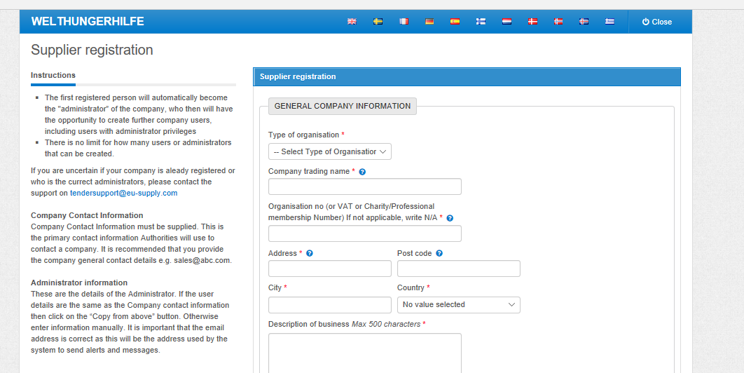

Please fill in all required data of your company. Please do not share your credentials for the portal with any third party. After all date is entered, please press “Save”! Your company is now registered.

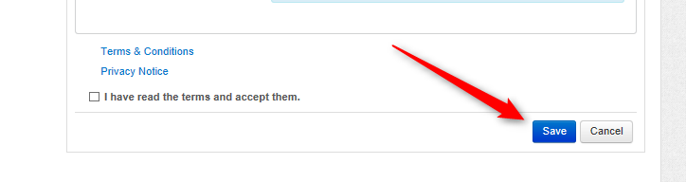

D – How to participate to an ongoing tender
You need to be registered as supplier in the WHH portal to be in the position to participate to a tender, thus successfully upload a bid. Means, unregistered suppliers cannot participate in the tender process and cannot upload any documents.
Those registered must express their interest for the participation to that specific tender first. This is possible by selecting the specific tender you would like to join.
Once the correct tender is selected, the view of the information page of the specific tender appears slightly different for registered and logged-in suppliers (refer to page 3 of this document). The buttons “Log in” and “Online registration” are exchanged with the button “Accept”.
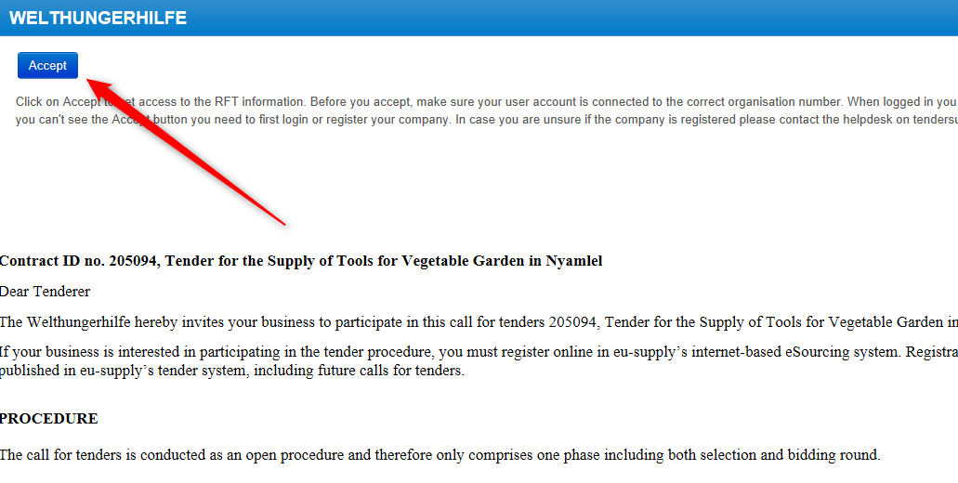
Please click on “Accept” if you would like to participate. You will be forwarded to the Supplier main page of this specific tender.

This is your Supplier main page for the specific tender:
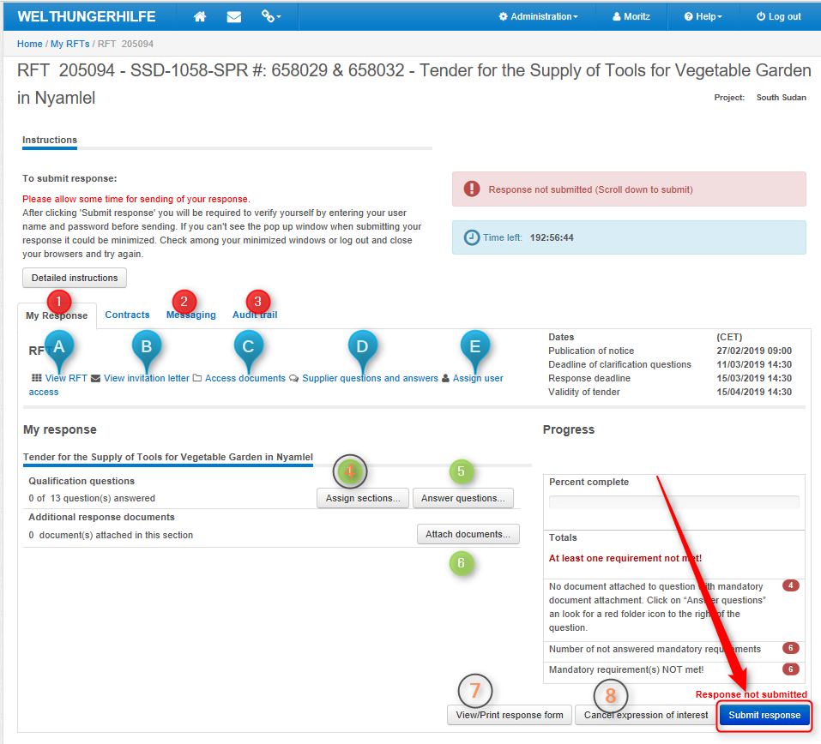
Some explanations:
1: The overview and current status of your response
2: Here you and submit messages to WHH
3: Your audit trail (you can see who dis what and when)
4: You can assign sections of the qualification questions to specific people (not mandatory)
5: Here you can view the questionnaire and answer the questions
6: Here you can upload your documents (those requested by WHH) and your offer
7: You can view/print your response (for your files)
8. For cancelling (in case you don’t want to participate anymore)
9: Most important: If all documents are uploaded and all questions answered you must submit your response!!!

Some explanations:
1a: To view the tender of WHH
1b: To view the invitation letter of WHH
1c: to view the documents of WHH
1d: To ask questions and view answers of WHH
1e: To assign more users which act on behalf of your company in the portal

E – How to answer a questionnaire
For some tenders the answering of a questionnaire is a mandatory step for the participation in the tender. To answer these questions simply click on the clicking the button “Answer questions” of the Supplier main page of the tender. Then you will reach page:
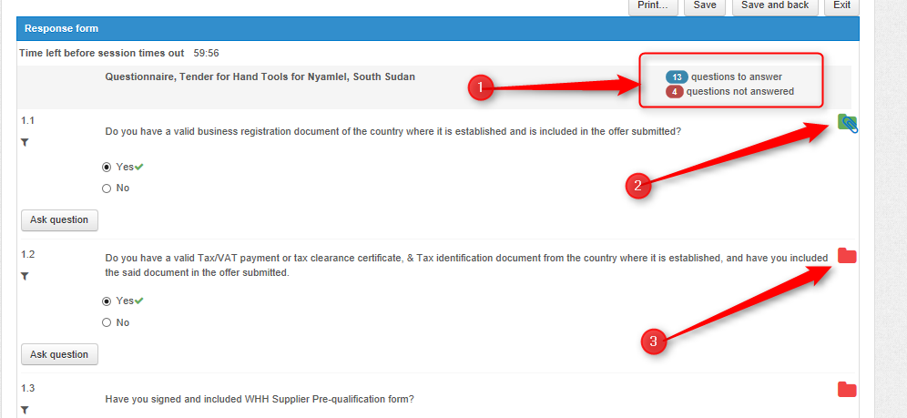
Some explanations:
1: Here you can see how many questions are to be answered and how many are still unanswered or incomplete. Remark: If documents are required to answer the question, these documents must be uploaded. Otherwise the question remains in the status "not answered".
2: Symbol for the successful upload of the required document (business registration).
3: Symbol which shows no document (tax clearance certificate) has been uploaded yet. Here you need to upload the requested document to change the status of this question into answered. Please confirm uploaded documents by clicking the “Save” button which can be found on the bottom of the questionnaire.

The offer can only be submitted if all questions have the status "answered". 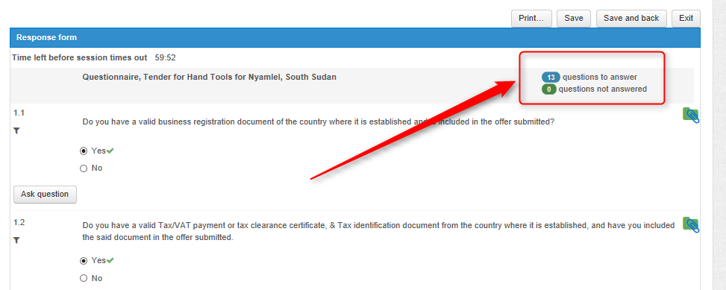

F – How to upload your bid
For the upload of documents please go to the Supplier main page for the specific tender. By clicking the button “Attach Documents”. you will reach the following page:
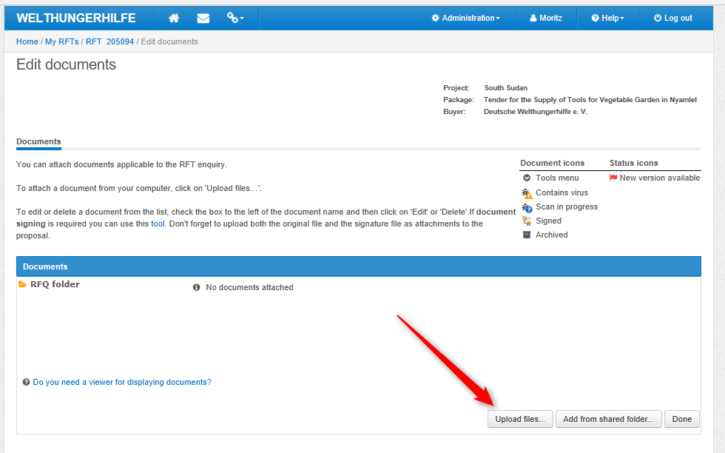
For the upload of documents (your offer, supporting documents such as BoQ, technical leaflets, VAT registration form, Reference list, etc.) simply click on the button “Upload files”.

By clicking the button “Upload files”. you will reach the following page:
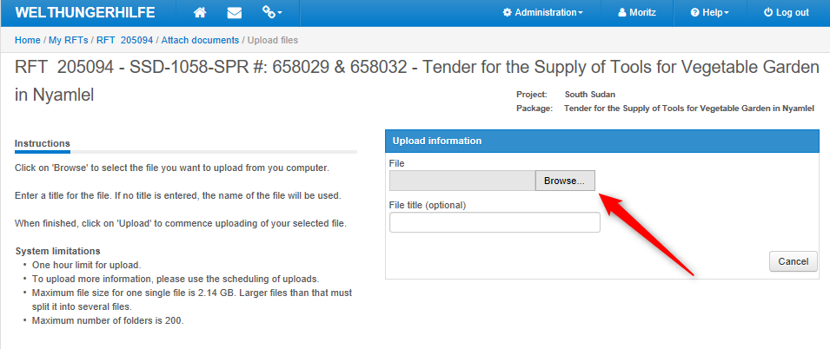
Simply follow the instructions on the right side of this page. By clicking on “Browse” you can select the file from your computer.
Once the selected file has been uploaded it will appear in the document overview:
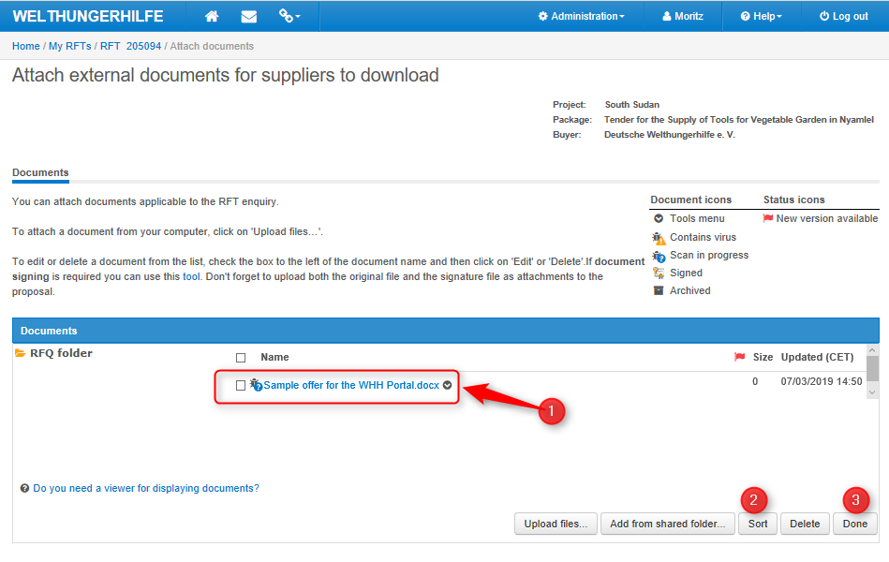
Some explanations:
1: The successful uploaded document
2: Here you can sort the uploaded documents
3: One all documents are uploaded press on “Done”

F – How to submit your bid
Once all requirements of the tender are fulfilled, means, all questions are answered, all supporting documents are uploaded to the respective answers, all other documents have been uploaded as well, you can now submit your bid.
Again, you start on the Supplier main page of the specific tender. Here you can see on the progress bar, that the requirement of the tender is fulfilled (100%). Means, you can now submit your bid by clicking on the button “Submit response”.
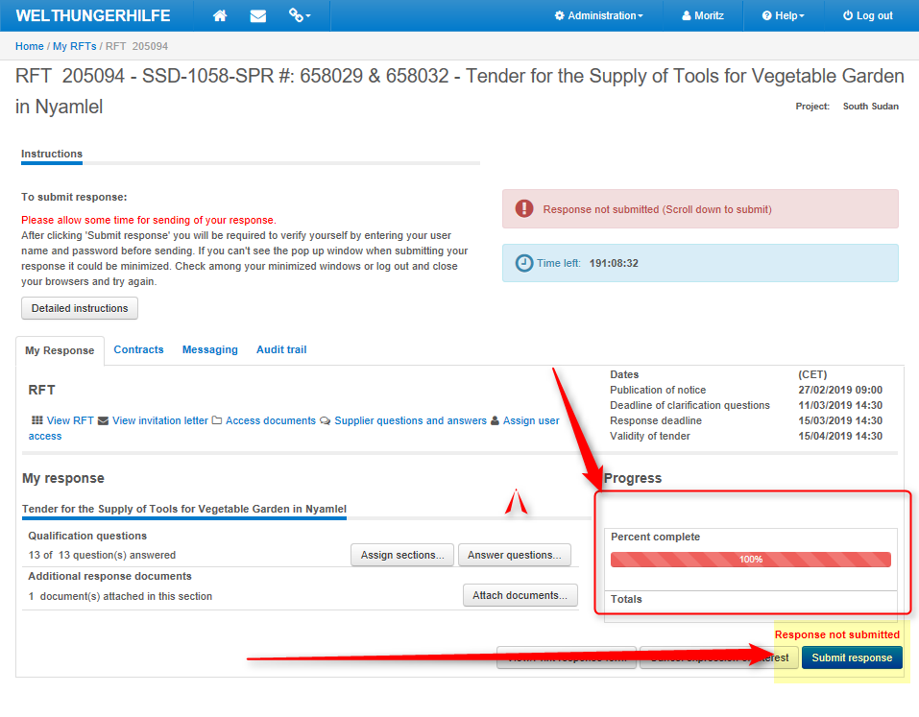

You need to verify yourself before submission. Please enter your credentials.
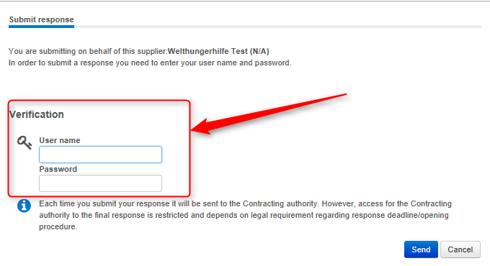
Your response has been successfully submitted to WHH. The progress bar turned from red into green! Congratulations!!!
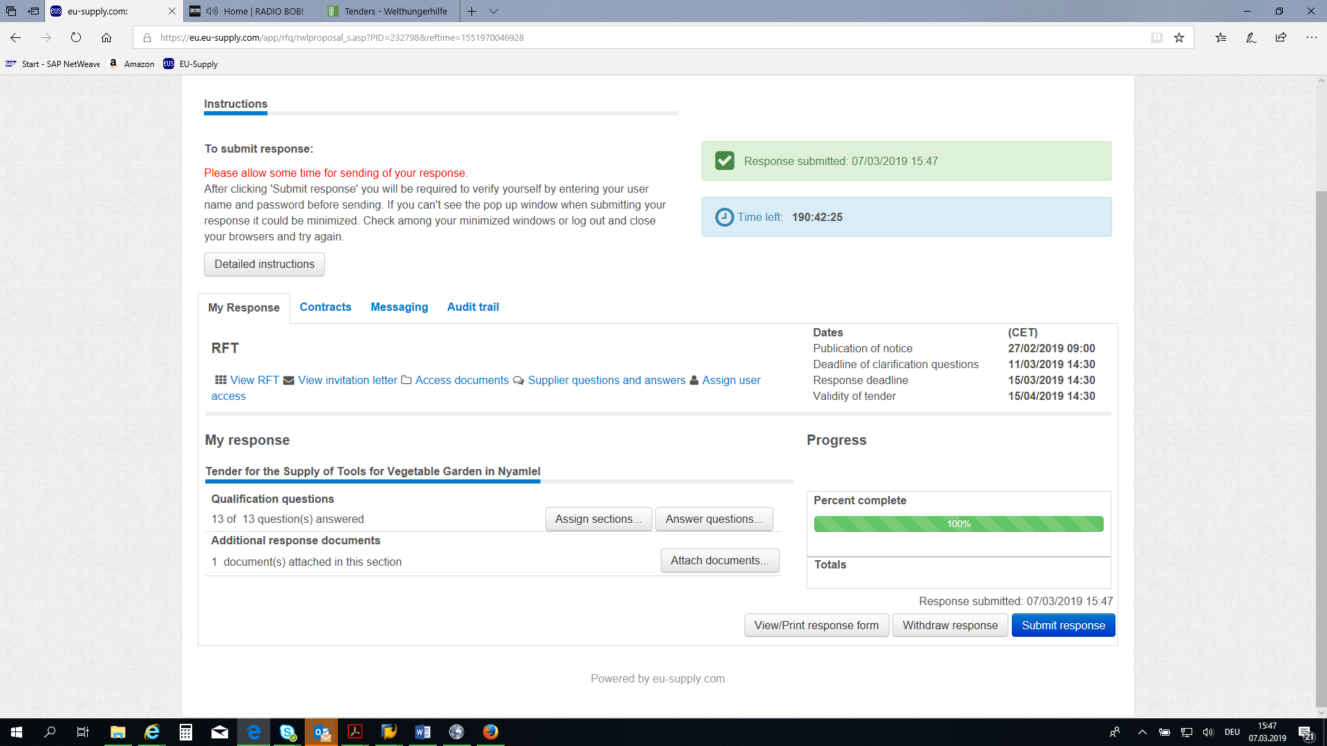

***

Refer to page 2 of this document, how to select the tender.

